**Book library system.**

What you will be building :

A classic online book library has all the features of a physical library. Online book library system should be user friendly and easy to understand . User should be able to perform below **functionality with the system:**

1. Adding the book with details like book name , book description , count ,author etc ..  (While adding you can save the book detail in redux store and leverage the same values while searching).

2. Searching the book

3. Editing a particular book detail

4. Also create a page with the list of all the books listed in the system.

Developer can develop the View of the. Web based on his/her liking . View should be as responsive as possible.

**Make sure to follow these points :**

1. Use framework of your choice either angular or react, if using angular use 4+

2. Use a state conatainer, flux or redux choice is yours

3. Do not use any css framework like material or bootstrap

4. Make sure your application looks good in mobile, tab and desktop (choose a design of your choice)

5. Use a build tool of your choice

6. Don’t spend time in making ui look better, spend time in having proper component based approach

7. typescript is preferred over javascript

**Good to have :**

1. Have a node js backend which will be used to read and persist books to a json file

2. UI will interact with Backend using proper http/rest calls

Once you are done send us github link for the app make sure to have proper Readme with steps to run this app

in case you are not in github, send us a zip file

**Solution Provided or Approach**

1. User can able to add / edit book by clicking the Add Book or Edit button provided against the record.
2. To delete user can click on the delete item on the right . On successful confirmation the book will be deleted
3. To Add/Edit book is provided with basic validation , Book count is resticted maximum 100
4. To search a book user can navigate to book search and there can be able to search a book by its category
5. Used HTTP calls for post/edit/get with json server
6. Not used any UI Frameworks

Steps to do

1. Download the library management system code from the git or zip file and uzip it in to the folder
2. Pre Requirements . Node v12.10.0 , json server installed in the machine
3. Do npm install ( I ) by going inside the folder
4. Start json server with json-server --watch db.json in the base folder

Screens Flow

Book List

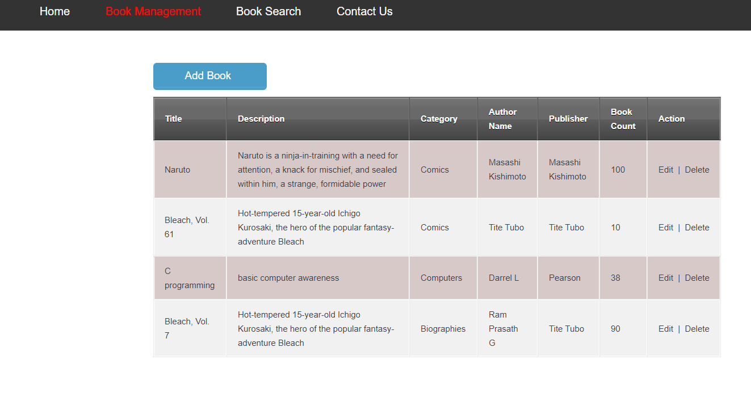

To Add New Book

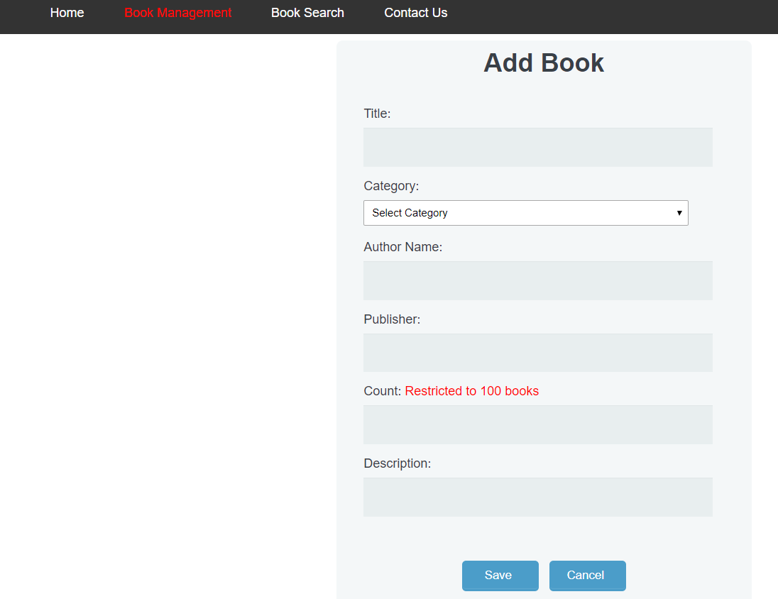

**Add book screen with validation**

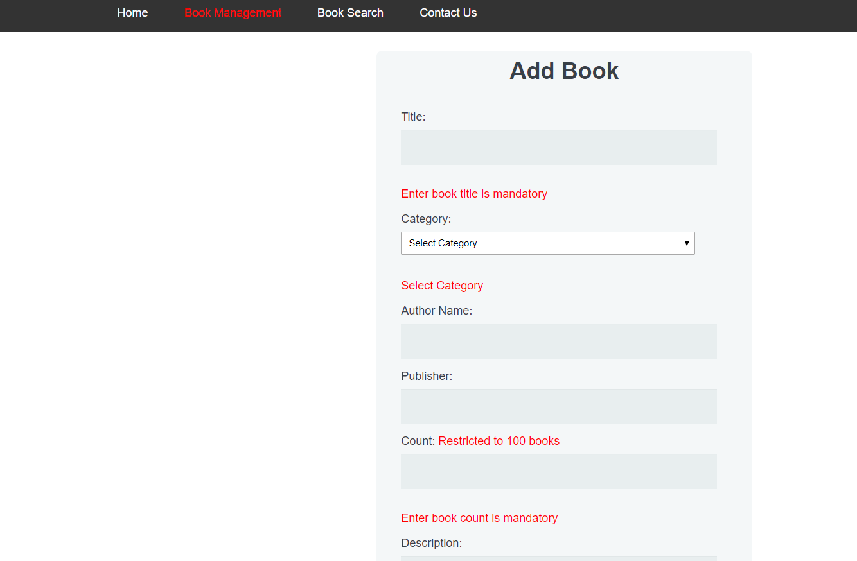

Edit Book Screen

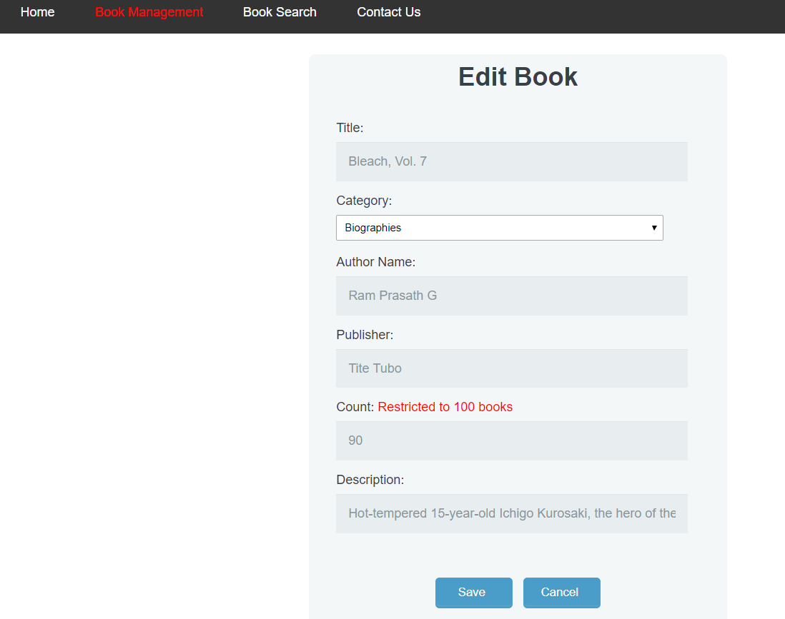

To Search a book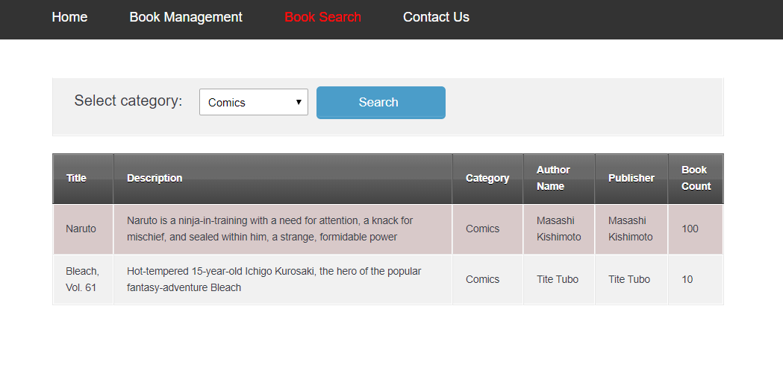

Build with AOT

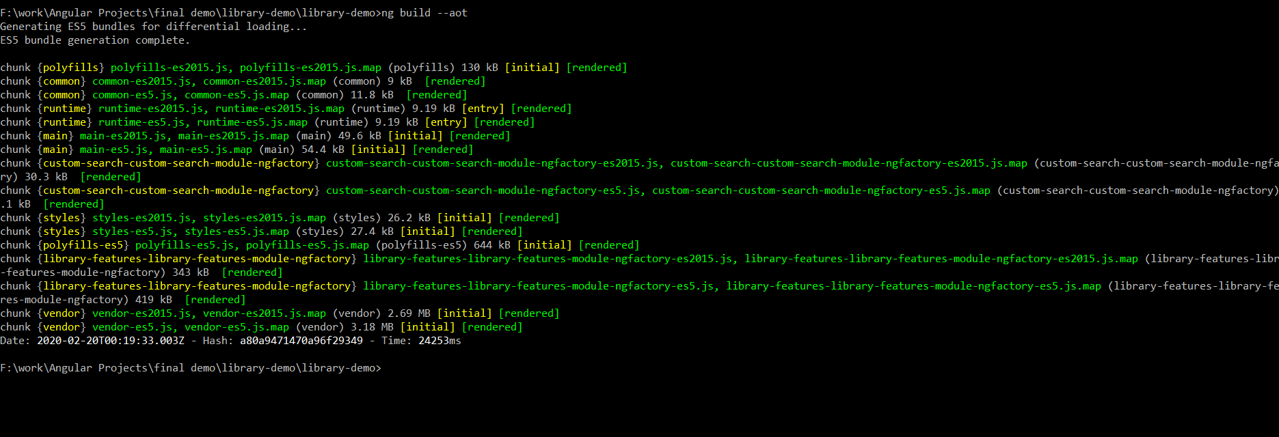

Built with production

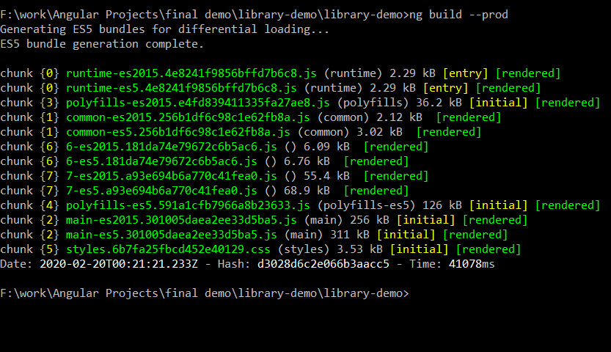

Folder Structure

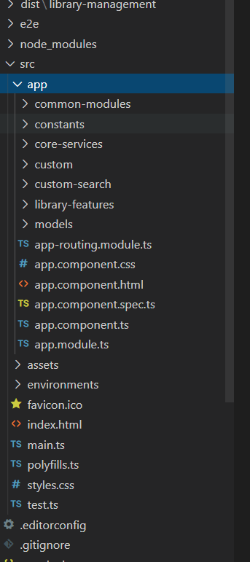

Unit test 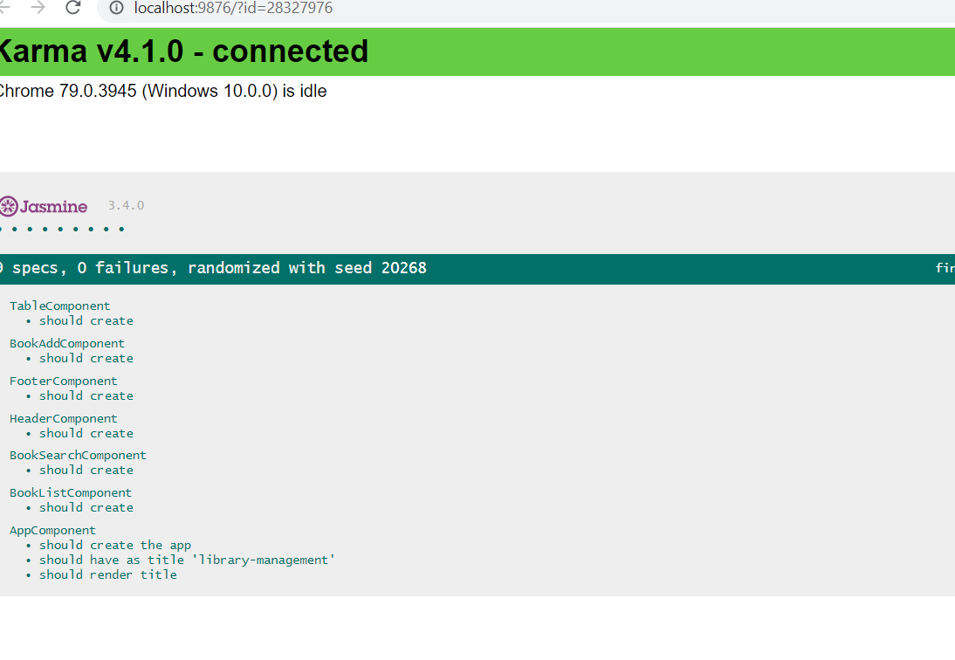

Lazy Loading concept

Implement lazy loading by keeping Book Management & Book Search in different module

